Brandon Salazar
CSE 020
Sept 19 2017

Answer Participation Activities
2.2.4,
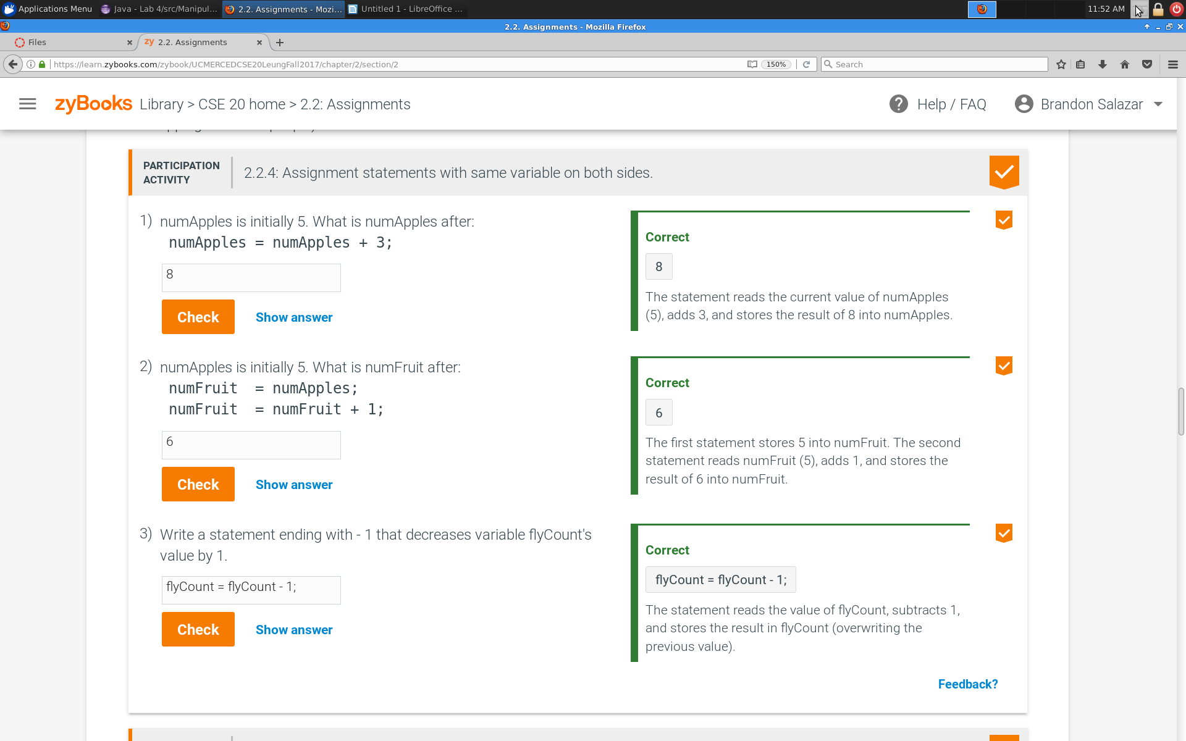
2.4.3,
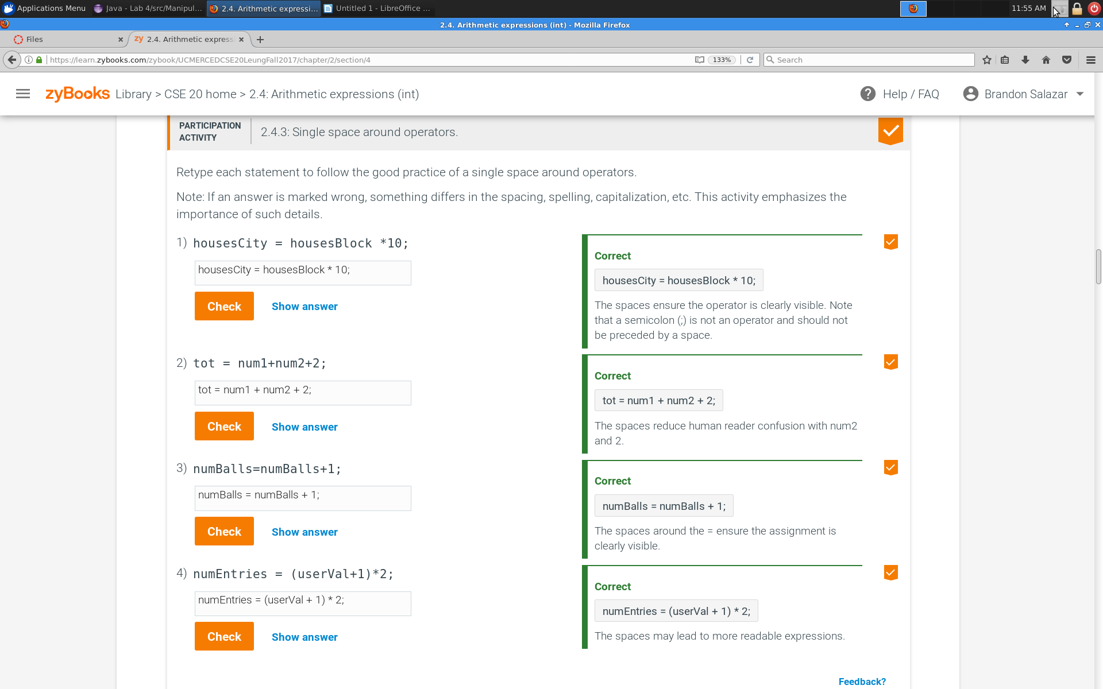

2.4.4,
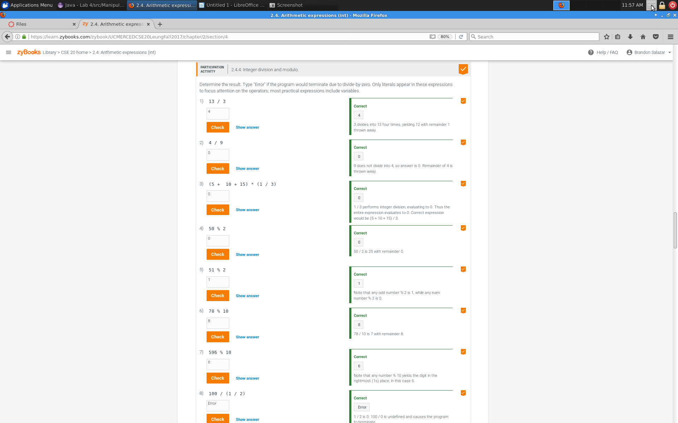

2.9.2,
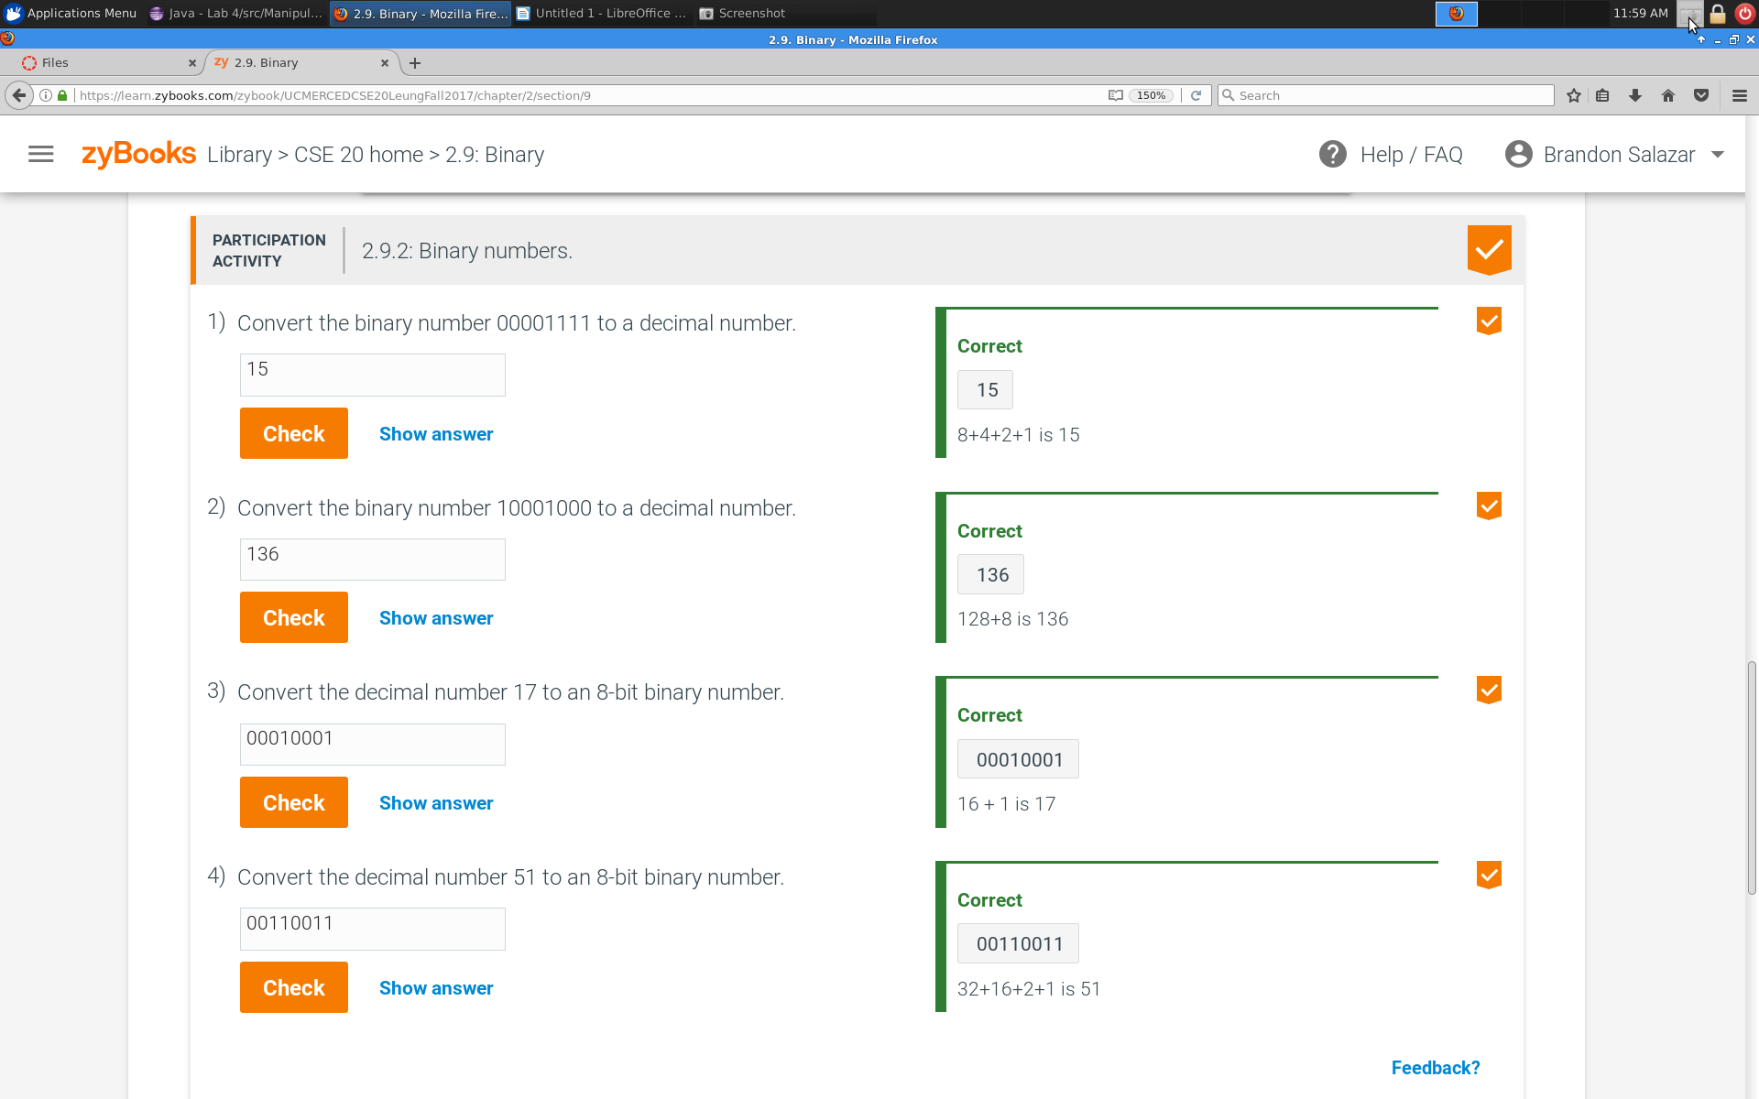

2.13.1

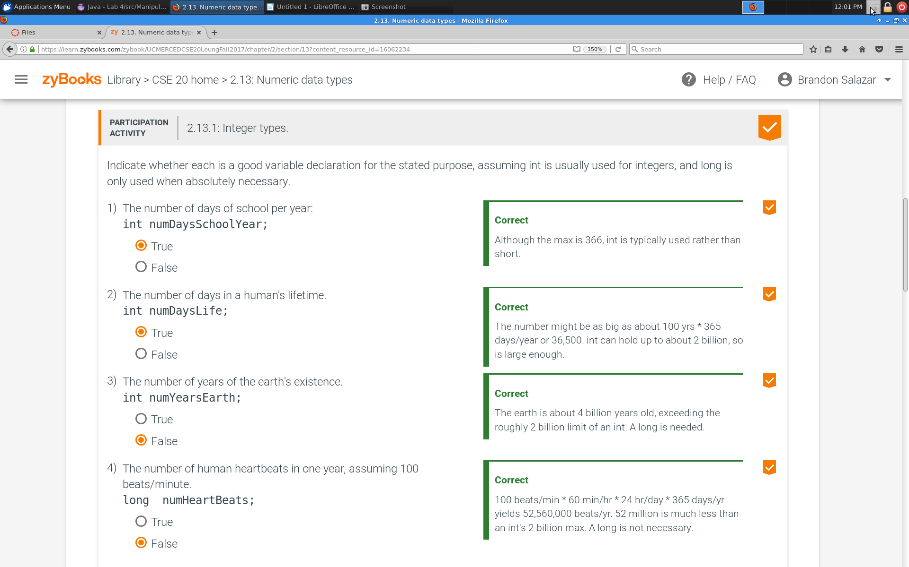
Assesment

-Give the expression for printing “OUTPUT is Z” using variable
charA by using type casting and manipulating it (like in the examples)

char charA = ‘A’;

System.out.print(“OUTPUT is “ + (char)(charA + 25));

-Are there certain numbers that do not work for input of Manipulate?
There are certain numbers that don’t work, for example Int won’t work with numbers that are less than -2,147,483,648 or greater than 2,147,483,648. Float will not work with any number greater than or less than -+3.4x10^+-38. Short will not work with numbers that are less than -32,768 or greater 32,767 and Doubles will not work with any number greater than or less than -+1.7x10^-+308

-Are there any output differences between floats and doubles?
Yes, double is WAY bigger than floats

-Can two large integers after some operation result in a short?
Yes as long as it is between the range of -32,768 and 32,767.

